# **U****se Case View**

*Package in package 'Model'*

Use Case View

Version Phase 1.0 Proposed

Veronika created on 14.02.2018. Last modified 14.02.2018

## **B****usiness**

*Package in package 'Use Case View'*

Бизнес-модель системы

Business

Version 1.0 Phase 1.0 Proposed

Veronika created on 21.02.2018. Last modified 08.03.2018

### **Business diagram**

*Use Case diagram in package 'Business '*

Данная

диаграмма дает дополнительное представление для разработчиков

АИС о возможных требованиях к функционалу со стороны заказчика

Business

Version 1.0

Veronika created on 21.02.2018. Last modified 08.03.2018

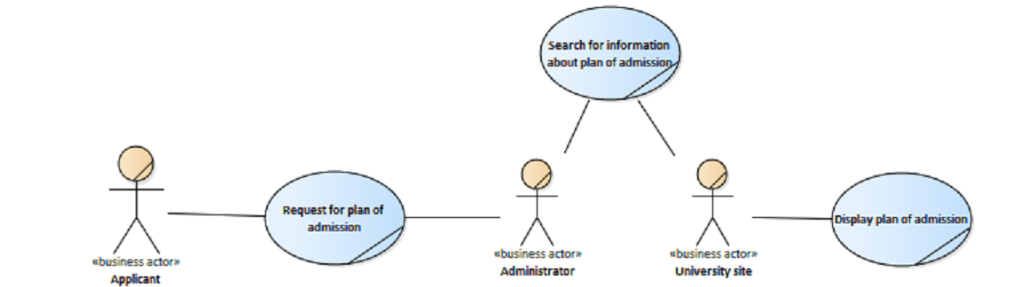

Business

### **Display plan of admission**

*UseCase «business use case» in package 'Business '*

Отображение плана приема

Display plan of admission

Version 1.0 Phase 1.0 Proposed

Veronika created on 27.02.2018. Last modified 08.03.2018

| **CONNECTORS** |
| --- |
| **Association** Unspecified  From: University site : Actor, Public  To: Display plan of admission : UseCase, Public |

### **Forming necessary request**

*UseCase «business use case» in package 'Business '*

Forming necessary request

Version 1.0 Phase 1.0 Proposed

Veronika created on 27.02.2018. Last modified 27.02.2018

| **CONNECTORS** |
| --- |
| **Generalization** Source -> Destination  From: Forming necessary request : UseCase, Public  To: Request for plan of admission : UseCase, Public |

### **Request for plan of admission**

*UseCase «business use case» in package 'Business '*

Сайт ВУЗа предоставляет список специальностей заданной формы обучения и планы приема

Request for plan of admission

Version 1.0 Phase 1.0 Proposed

Veronika created on 27.02.2018. Last modified 08.03.2018

| **CONNECTORS** |
| --- |
| **Association** Unspecified  From: Request for plan of admission : UseCase, Public  To: Administrator : Actor, Public |

|  |
| --- |
| **Generalization** Source -> Destination  From: Forming necessary request : UseCase, Public  To: Request for plan of admission : UseCase, Public |

|  |
| --- |
| **Association** Unspecified  From: Applicant : Actor, Public  To: Request for plan of admission : UseCase, Public |

|  |
| --- |
| **Generalization** Source -> Destination  From: Submit general information : UseCase, Public  To: Request for plan of admission : UseCase, Public |

### **Search for information about plan of admission**

*UseCase «business use case» in package 'Business '*

Поиск информации для отображения плана приема

Search for information about plan of admission

Version 1.0 Phase 1.0 Proposed

Veronika created on 27.02.2018. Last modified 08.03.2018

| **CONNECTORS** |
| --- |
| **Association** Unspecified  From: Search for information about plan of admission : UseCase, Public  To: University site : Actor, Public |

|  |
| --- |
| **Association** Unspecified  From: Search for information about plan of admission : UseCase, Public  To: Administrator : Actor, Public |

### **Submit general information**

*UseCase «business use case» in package 'Business '*

Submit general information

Version 1.0 Phase 1.0 Proposed

Veronika created on 27.02.2018. Last modified 27.02.2018

| **CONNECTORS** |
| --- |
| **Generalization** Source -> Destination  From: Submit general information : UseCase, Public  To: Request for plan of admission : UseCase, Public |

### **Update information**

*UseCase «business use case» in package 'Business '*

Update information

Version 1.0 Phase 1.0 Proposed

Veronika created on 27.02.2018. Last modified 27.02.2018

| **CONNECTORS** |
| --- |
| **Association** Unspecified  From: Update information : UseCase, Public  To: Administrator : Actor, Public |

|  |
| --- |
| **Association** Unspecified  From: Update information : UseCase, Public  To: University site : Actor, Public |

## **Main**

*Package in package 'Use Case View'*

Главная use-case диаграмму, отображающая функционал

будущей АИС (поведение системы с точки зрения разработчика)

Main

Version 1.0 Phase 1.0 Proposed

Veronika created on 27.02.2018. Last modified 08.03.2018

### **Main diagram**

*Use Case diagram in package 'Main'*

Главная use-case диаграмму, отображающая функционал будущей АИС

Main

Version 1.0

Veronika created on 27.02.2018. Last modified 08.03.2018

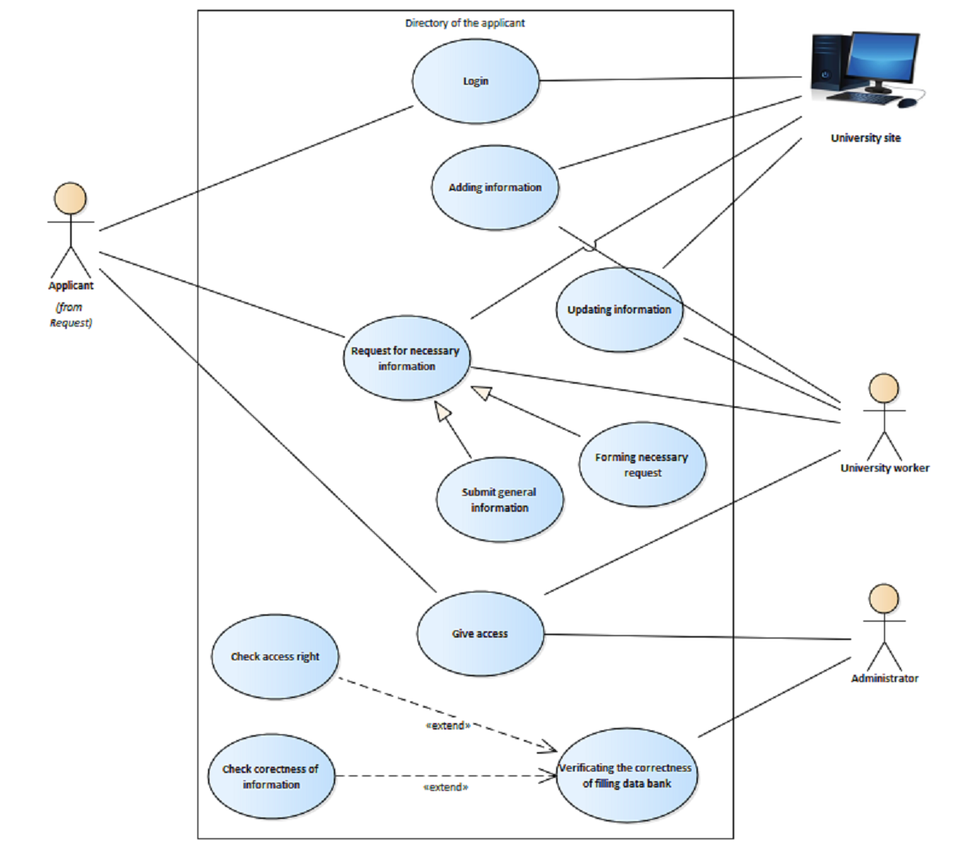

Main

### **Adding information**

*UseCase in package 'Main'*

Добавление необходимой информации на University site (специальности, кафедры и т.д)

Adding information

Version 1.0 Phase 1.0 Proposed

Veronika created on 27.02.2018. Last modified 27.02.2018

| **EXTERNAL REQUIREMENTS** |
| --- |
| Requirement. Ability to add information  University worker должен иметь возможность добавлять информацию в Data bank  [ Stereotype is «Functional». ] |

| **CONNECTORS** |
| --- |
| **Realization** Source -> Destination  From: Adding information : UseCase, Public  To: Ability to add information : Requirement, Public |

|  |
| --- |
| **Include** «include» Source -> Destination  From: Add speciality/department/faculty : UseCase, Public  To: Adding information : UseCase, Public |

|  |
| --- |
| **Include** «include» Source -> Destination  From: Add address : UseCase, Public  To: Adding information : UseCase, Public |

|  |
| --- |
| **Include** «include» Source -> Destination  From: Add phone numbers : UseCase, Public  To: Adding information : UseCase, Public |

|  |
| --- |
| **Association** Unspecified  From: University site : Actor, Public  To: Adding information : UseCase, Public |

|  |
| --- |
| **Association** Unspecified  From: University worker : Actor, Public  To: Adding information : UseCase, Public |

|  |
| --- |
| **Include** «include» Source -> Destination  From: Add form of education : UseCase, Public  To: Adding information : UseCase, Public |

|  |
| --- |
| **Include** «include» Source -> Destination  From: Add name, scientific degree and scientific rank of leaders : UseCase, Public  To: Adding information : UseCase, Public |

|  |
| --- |
| **Include** «include» Source -> Destination  From: Add website address : UseCase, Public  To: Adding information : UseCase, Public |

### **Check access right**

*UseCase in package 'Main'*

проверка уровеня доступа пользователя

Check access right

Version 1.0 Phase 1.0 Proposed

Veronika created on 27.02.2018. Last modified 08.03.2018

| **EXTERNAL REQUIREMENTS** |
| --- |
| Requirement. Check access right  Администратор(Administrator) должен проверять право доступа пользователей  [ Stereotype is «Functional». ] |

| **CONNECTORS** |
| --- |
| **Extend** «extend» Source -> Destination  From: Check access right : UseCase, Public  To: Verificating the correctness of filling data bank : UseCase, Public |

|  |
| --- |
| **Realization** Source -> Destination  From: Check access right : UseCase, Public  To: Check access right : Requirement, Public |

### **Check corectness of information**

*UseCase in package 'Main'*

Проверка правильности введенной информации

Check corectness of information

Version 1.0 Phase 1.0 Proposed

Veronika created on 27.02.2018. Last modified 08.03.2018

| **EXTERNAL REQUIREMENTS** |
| --- |
| Requirement. Check corectness of information  Администратор(Administrator) должен проверять правильность введенной информации  [ Stereotype is «Functional». ] |

| **CONNECTORS** |
| --- |
| **Realization** Source -> Destination  From: Check corectness of information : UseCase, Public  To: Check corectness of information : Requirement, Public |

|  |
| --- |
| **Extend** «extend» Source -> Destination  From: Check corectness of information : UseCase, Public  To: Verificating the correctness of filling data bank : UseCase, Public |

### **Forming necessary request**

*UseCase in package 'Main'*

Формирование запроса в системе

Forming necessary request

Version 1.0 Phase 1.0 Proposed

Veronika created on 27.02.2018. Last modified 08.03.2018

| **CONNECTORS** |
| --- |
| **Generalization** Source -> Destination  From: Forming necessary request : UseCase, Public  To: Request for necessary information : UseCase, Public |

### **Give access**

*UseCase in package 'Main'*

Администратор предоставляет различные уровни доступа для пользователей

Give access

Version 1.0 Phase 1.0 Proposed

Veronika created on 27.02.2018. Last modified 28.02.2018

| **EXTERNAL REQUIREMENTS** |
| --- |
| Requirement. Give access  Администратор(Administrator) должен предоставлять доступ к системе для пользователей с соответствующим уровнем доступа  [ Stereotype is «Functional». ] |

| **CONNECTORS** |
| --- |
| **Realization** Source -> Destination  From: Give access : UseCase, Public  To: Give access : Requirement, Public |

|  |
| --- |
| **Association** Unspecified  From: Give access : UseCase, Public  To: Applicant : Actor, Public |

|  |
| --- |
| **Association** Unspecified  From: Give access : UseCase, Public  To: University worker : Actor, Public |

|  |
| --- |
| **Association** Unspecified  From: Administrator : Actor, Public  To: Give access : UseCase, Public |

### **Login**

*UseCase in package 'Main'*

Авторизация в системе

Login

Version 1.0 Phase 1.0 Proposed

Veronika created on 27.02.2018. Last modified 28.02.2018

| **EXTERNAL REQUIREMENTS** |
| --- |
| Requirement. Ability to login  Пользователь должен иметь возможность авторизоваться на сайте  [ Stereotype is «Functional». ] |

| **CONNECTORS** |
| --- |
| **Association** Unspecified  From: Login : UseCase, Public  To: University site : Actor, Public |

|  |
| --- |
| **Realization** Source -> Destination  From: Login : UseCase, Public  To: Ability to login : Requirement, Public |

|  |
| --- |
| **Association** Unspecified  From: Applicant : Actor, Public  To: Login : UseCase, Public |

### **Request for necessary information**

*UseCase in package 'Main'*

Абитуриент запрашивает необходимую информацию

Request for necessary information

Version 1.0 Phase 1.0 Proposed

Veronika created on 27.02.2018. Last modified 28.02.2018

| **EXTERNAL REQUIREMENTS** |
| --- |
| Requirement. Ability to choose requests  Абитуриент(Applicant) должен иметь возможность выбирать различные запросы на сайте(University site)  [ Stereotype is «Functional». ] |

|  |
| --- |
| Requirement. Ability to get answer  Абитуриент(Applicant) должен иметь возможность получить ответ на свой запрос(сведения об ошибке в случае некорректного запроса)  [ Stereotype is «Functional». ] |

| **CONNECTORS** |
| --- |
| **Association** Unspecified  From: Request for necessary information : UseCase, Public  To: University worker : Actor, Public |

|  |
| --- |
| **Association** Unspecified  From: Request for necessary information : UseCase, Public  To: University site : Actor, Public |

|  |
| --- |
| **Realization** Source -> Destination  From: Request for necessary information : UseCase, Public  To: Ability to get answer : Requirement, Public |

|  |
| --- |
| **Realization** Source -> Destination  From: Request for necessary information : UseCase, Public  To: Ability to choose requests : Requirement, Public |

|  |
| --- |
| **Generalization** Source -> Destination  From: Submit general information : UseCase, Public  To: Request for necessary information : UseCase, Public |

|  |
| --- |
| **Generalization** Source -> Destination  From: Forming necessary request : UseCase, Public  To: Request for necessary information : UseCase, Public |

|  |
| --- |
| **Association** Unspecified  From: Applicant : Actor, Public  To: Request for necessary information : UseCase, Public |

### **Submit general information**

*UseCase in package 'Main'*

Отправка информации в целом

Submit general information

Version 1.0 Phase 1.0 Proposed

Veronika created on 27.02.2018. Last modified 08.03.2018

| **CONNECTORS** |
| --- |
| **Generalization** Source -> Destination  From: Submit general information : UseCase, Public  To: Request for necessary information : UseCase, Public |

### **Updating information**

*UseCase in package 'Main'*

Обновление информации, хранящейся в Data bank

Updating information

Version 1.0 Phase 1.0 Proposed

Veronika created on 27.02.2018. Last modified 27.02.2018

| **EXTERNAL REQUIREMENTS** |
| --- |
| Requirement. Ability to update information  University worker должен иметь возможность обновлять информацию в Data bank  [ Stereotype is «Functional». ] |

| **CONNECTORS** |
| --- |
| **Realization** Source -> Destination  From: Updating information : UseCase, Public  To: Ability to update information : Requirement, Public |

|  |
| --- |
| **Include** «include» Source -> Destination  From: Plan of admission : UseCase, Public  To: Updating information : UseCase, Public |

|  |
| --- |
| **Association** Unspecified  From: University worker : Actor, Public  To: Updating information : UseCase, Public |

|  |
| --- |
| **Include** «include» Source -> Destination  From: History of leaders : UseCase, Public  To: Updating information : UseCase, Public |

|  |
| --- |
| **Include** «include» Source -> Destination  From: Max passing score : UseCase, Public  To: Updating information : UseCase, Public |

|  |
| --- |
| **Association** Unspecified  From: University site : Actor, Public  To: Updating information : UseCase, Public |

|  |
| --- |
| **Include** «include» Source -> Destination  From: List of subjects : UseCase, Public  To: Updating information : UseCase, Public |

### **Verificating the correctness of filling data bank**

*UseCase in package 'Main'*

Проверка правильности заполнения банка данных

Verificating the correctness of filling data bank

Version 1.0 Phase 1.0 Proposed

Veronika created on 27.02.2018. Last modified 28.02.2018

| **CONNECTORS** |
| --- |
| **Extend** «extend» Source -> Destination  From: Check access right : UseCase, Public  To: Verificating the correctness of filling data bank : UseCase, Public |

|  |
| --- |
| **Association** Unspecified  From: Administrator : Actor, Public  To: Verificating the correctness of filling data bank : UseCase, Public |

|  |
| --- |
| **Extend** «extend» Source -> Destination  From: Check corectness of information : UseCase, Public  To: Verificating the correctness of filling data bank : UseCase, Public |

## **Manage Information**

*Package in package 'Use Case View'*

Дополнительная use-case диаграмма, которая отображает процесс управления информацией в банке данных

Manage Information

Version 1.0 Phase 1.0 Proposed

Veronika created on 27.02.2018. Last modified 08.03.2018

| **SCENARIOS** |
| --- |
| Basic Path. Manage information  1. University worker заходит на University site  Uses:  2. Проверка уровня доступа пользователя  Uses:  3. University worker вносит изменения или обновляет информацию  Uses:  Alternate: *3a*. Access is denied |

|  |
| --- |
| Alternate. Access is denied  1. University site запрещает редактирование и добавление информации  Uses: |

### **Manage Information diagram**

*Use Case diagram in package 'Manage Information'*

Управление информацией в банке данных

Manage Information

Version 1.0

Veronika created on 27.02.2018. Last modified 05.03.2018

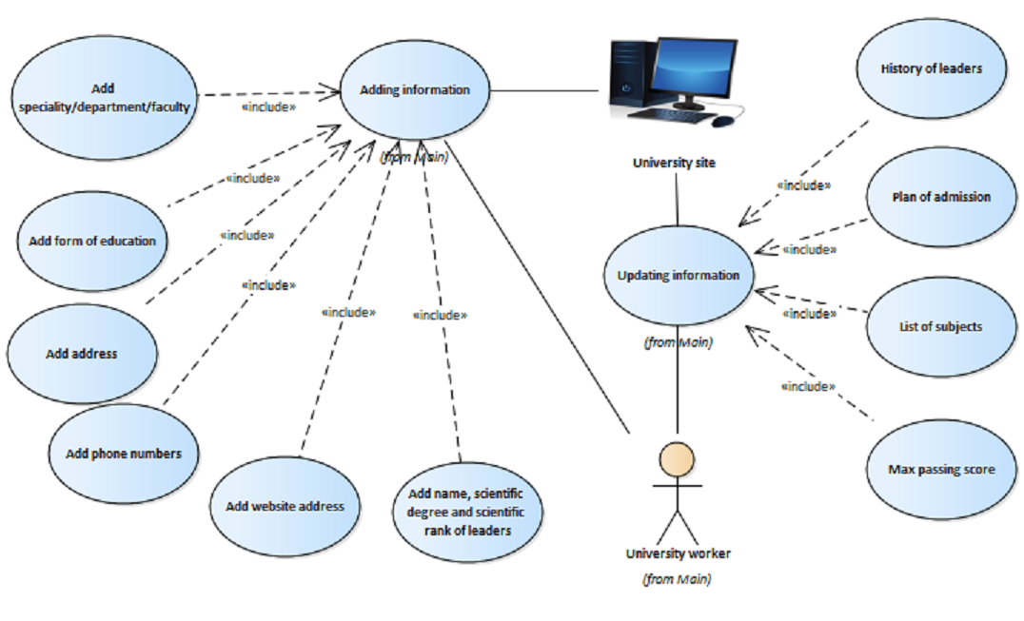

Manage Information

### **Add address**

*UseCase in package 'Manage Information'*

Добавление Address

Add address

Version 1.0 Phase 1.0 Proposed

Veronika created on 28.02.2018. Last modified 28.02.2018

| **CONNECTORS** |
| --- |
| **Include** «include» Source -> Destination  From: Add address : UseCase, Public  To: Adding information : UseCase, Public |

### **Add form of education**

*UseCase in package 'Manage Information'*

Добавление форм обучения(Extramural form of education, Intramural form of education, Part-time form of education)

Add form of education

Version 1.0 Phase 1.0 Proposed

Veronika created on 28.02.2018. Last modified 28.02.2018

| **CONNECTORS** |
| --- |
| **Include** «include» Source -> Destination  From: Add form of education : UseCase, Public  To: Adding information : UseCase, Public |

### **Add name, scientific degree and scientific rank of leaders**

*UseCase in package 'Manage Information'*

Добавление Name, Scientific degree и Scientific rank

Add name, scientific degree and scientific rank of leaders

Version 1.0 Phase 1.0 Proposed

Veronika created on 28.02.2018. Last modified 28.02.2018

| **CONNECTORS** |
| --- |
| **Include** «include» Source -> Destination  From: Add name, scientific degree and scientific rank of leaders : UseCase, Public  To: Adding information : UseCase, Public |

### **Add phone numbers**

*UseCase in package 'Manage Information'*

Добавление Phone number

Add phone numbers

Version 1.0 Phase 1.0 Proposed

Veronika created on 28.02.2018. Last modified 28.02.2018

| **CONNECTORS** |
| --- |
| **Include** «include» Source -> Destination  From: Add phone numbers : UseCase, Public  To: Adding information : UseCase, Public |

### **Add speciality/department/faculty**

*UseCase in package 'Manage Information'*

Добавление информации о специальностях(Speciality), кафедрах(Department), факультетах(Faculty)

Add speciality/department/faculty

Version 1.0 Phase 1.0 Proposed

Veronika created on 28.02.2018. Last modified 28.02.2018

| **CONNECTORS** |
| --- |
| **Include** «include» Source -> Destination  From: Add speciality/department/faculty : UseCase, Public  To: Adding information : UseCase, Public |

### **Add website address**

*UseCase in package 'Manage Information'*

Добавление Site address

Add website address

Version 1.0 Phase 1.0 Proposed

Veronika created on 28.02.2018. Last modified 28.02.2018

| **CONNECTORS** |
| --- |
| **Include** «include» Source -> Destination  From: Add website address : UseCase, Public  To: Adding information : UseCase, Public |

### **History of leaders**

*UseCase in package 'Manage Information'*

Ведение History of all heads

History of leaders

Version 1.0 Phase 1.0 Proposed

Veronika created on 28.02.2018. Last modified 08.03.2018

| **CONNECTORS** |
| --- |
| **Include** «include» Source -> Destination  From: History of leaders : UseCase, Public  To: Updating information : UseCase, Public |

### **List of subjects**

*UseCase in package 'Manage Information'*

Составление List of subjects

List of subjects

Version 1.0 Phase 1.0 Proposed

Veronika created on 28.02.2018. Last modified 28.02.2018

| **CONNECTORS** |
| --- |
| **Include** «include» Source -> Destination  From: List of subjects : UseCase, Public  To: Updating information : UseCase, Public |

### **Max passing score**

*UseCase in package 'Manage Information'*

Вычисление максимального Passing score

Max passing score

Version 1.0 Phase 1.0 Proposed

Veronika created on 28.02.2018. Last modified 08.03.2018

| **CONNECTORS** |
| --- |
| **Include** «include» Source -> Destination  From: Max passing score : UseCase, Public  To: Updating information : UseCase, Public |

### **Plan of admission**

*UseCase in package 'Manage Information'*

Составление Plan of admission

Plan of admission

Version 1.0 Phase 1.0 Proposed

Veronika created on 28.02.2018. Last modified 08.03.2018

| **CONNECTORS** |
| --- |
| **Include** «include» Source -> Destination  From: Plan of admission : UseCase, Public  To: Updating information : UseCase, Public |

## **Request**

*Package in package 'Use Case View'*

Дополнительная use-case диаграмма, которая отображает процесс обработки запросов

Request

Version 1.0 Phase 1.0 Proposed

Veronika created on 16.02.2018. Last modified 08.03.2018

| **SCENARIOS** |
| --- |
| Basic Path. Main  Applicant заходит на University site. В зависимости от выбора действия выполняется один из дополнительных сценариев  1. Applicant заходит на University site  Uses:  2. Applicant выбирает опцию  Uses:  3. University site завершает работу  Uses:  Alternate: *3a*. Display speciality with max passing score  Alternate: *3b*. Display list of leaders  Alternate: *3c*. Display plan of admission |

|  |
| --- |
| Alternate. Display speciality with max passing score  C:\Users\Veronika\Desktop\программирование\лабы_4\PPS\MaxPassingScoreScenario.txt  1. На University site отображается поле для ввода года  Uses:  2. University site отображает наименование специальности (Speciality), на которую в заданном году был максимальный проходной балл(Passing score) по математике  Uses: |

|  |
| --- |
| Alternate. Display list of leaders  C:\Users\Veronika\Desktop\программирование\лабы_4\PPS\ListOfLeadersScenario.txt  1. На University site отображается поле для ввода года  Uses:  2. University site отображает List of leaders  Uses: |

|  |
| --- |
| Alternate. Display plan of admission  C:\Users\Veronika\Desktop\программирование\лабы_4\PPS\PlanOfAdmissionScenario.txt  1. На University site отображается поле для ввода года  Uses:  2. На University site отображается поле для ввода формы обучения  Uses:  3. University site отображает List of specialties и Plan of admission  Uses: |

|  |
| --- |
| Exception. Invalid year |

### **InvalidForm_ActivityGraph diagram**

*Activity diagram in package 'Request'*

InvalidForm_ActivityGraph

Version 1.0

Veronika created on 08.03.2018. Last modified 08.03.2018

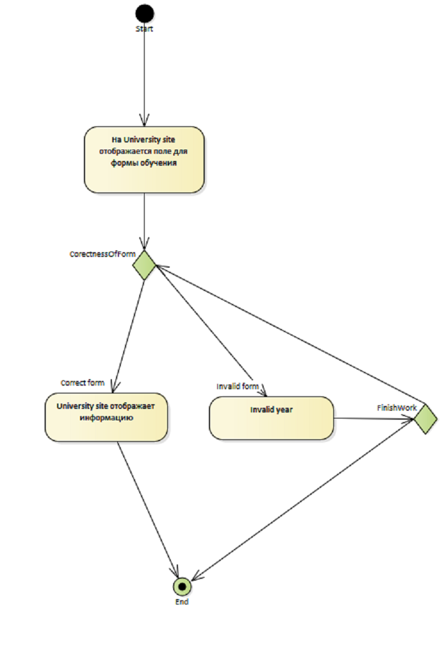

InvalidForm_ActivityGraph

### **InvalidYear_ActivityGraph diagram**

*Activity diagram in package 'Request'*

InvalidYear_ActivityGraph

Version 1.0

Veronika created on 08.03.2018. Last modified 08.03.2018



InvalidYear_ActivityGraph

### **Request diagram**

*Use Case diagram in package 'Request'*

Процесс обработки запросов

Request

Version 1.0

Veronika created on 16.02.2018. Last modified 08.03.2018

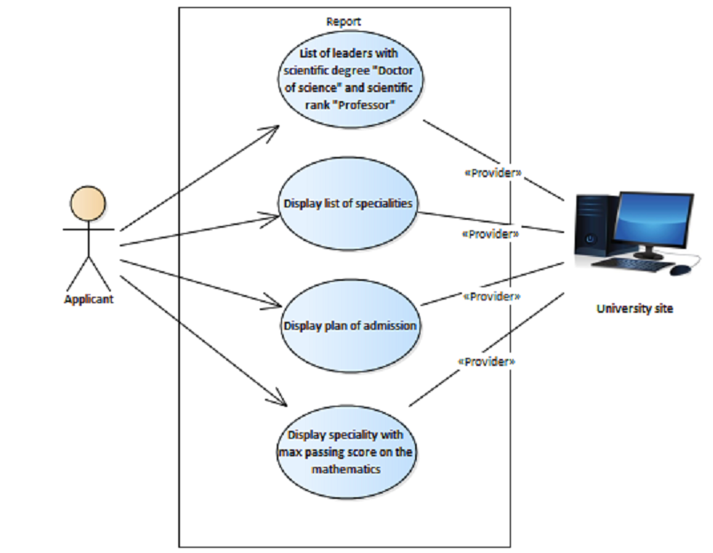

Request

### **Display list of specialities**

*UseCase in package 'Request'*

Отображает список специальностей( List of specialties)

Display list of specialities

Version 1.0 Phase 1.0 Proposed

Veronika created on 20.02.2018. Last modified 20.02.2018

| **CONNECTORS** |
| --- |
| **Provider** «Provider» Unspecified  From: University site : Actor, Public  To: Display list of specialities : UseCase, Public |

|  |
| --- |
| **Association** Source -> Destination  From: Applicant : Actor, Public  To: Display list of specialities : UseCase, Public |

### **Display plan of admission**

*UseCase in package 'Request'*

Отображает план приема (Plan of admission)

Display plan of admission

Version 1.0 Phase 1.0 Proposed

Veronika created on 20.02.2018. Last modified 20.02.2018

| **CONNECTORS** |
| --- |
| **Provider** «Provider» Unspecified  From: University site : Actor, Public  To: Display plan of admission : UseCase, Public |

|  |
| --- |
| **Association** Source -> Destination  From: Applicant : Actor, Public  To: Display plan of admission : UseCase, Public |

### **Display speciality with max passing score on the mathematics**

*UseCase in package 'Request'*

отображает специальность

(Speciality) с максимальным проходным баллом (Passing score)

Display speciality with max passing score on the mathematics

Version 1.0 Phase 1.0 Proposed

Veronika created on 20.02.2018. Last modified 20.02.2018

| **CONNECTORS** |
| --- |
| **Association** Source -> Destination  From: Applicant : Actor, Public  To: Display speciality with max passing score on the mathematics : UseCase, Public |

|  |
| --- |
| **Provider** «Provider» Unspecified  From: University site : Actor, Public  To: Display speciality with max passing score on the mathematics : UseCase, Public |

### **List of leaders with scientific degree "Doctor of science" and scientific rank "Professor"**

*UseCase in package 'Request'*

Отображает список руководителей

List of leaders with scientific degree "Doctor of science" and scientific rank "Professor"

Version 1.0 Phase 1.0 Proposed

Veronika created on 20.02.2018. Last modified 08.03.2018

| **CONNECTORS** |
| --- |
| **Association** Source -> Destination  From: Applicant : Actor, Public  To: List of leaders with scientific degree "Doctor of science" and scientific rank "Professor" : UseCase, Public |

|  |
| --- |
| **Provider** «Provider» Unspecified  From: University site : Actor, Public  To: List of leaders with scientific degree "Doctor of science" and scientific rank "Professor" : UseCase, Public |

## **Verification of corectness of filling data bank**

*Package in package 'Use Case View'*

Дополнительная use-case диаграмма, которая отображает процесс проверки правильности заполнения банка данных

Verification of corectness of filling data bank

Version 1.0 Phase 1.0 Proposed

Veronika created on 27.02.2018. Last modified 08.03.2018

| **SCENARIOS** |
| --- |
| Basic Path. Verification  1. Applicant хочет внести изменения или добавить информацию в банк данных(Data bank)  Uses:  2. Проверка, достаточный ли у пользователя (Applicant) уровень доступа для редактирования и добавления данных  Uses:  3. Проверка корректности ввода данных  Uses:  Alternate: *3a*. Access is denied  4. Изменения вносятся в Data bank  Uses:  Alternate: *4a*. Incorrect data |

|  |
| --- |
| Alternate. Access is denied  1. University site запрещает редактирование и добавление информации  Uses: |

|  |
| --- |
| Alternate. Incorrect data  1. University site запрещает редактирование и добавление информации  Uses: |

### **Verification of corectness of filling data bank diagram**

*Use Case diagram in package 'Verification of corectness of filling data bank'*

Администратор(Administrator) проверяет правильность заполнения и редактирования банка данных(Data bank)

Verification of corectness of filling data bank

Version 1.0

Veronika created on 27.02.2018. Last modified 08.03.2018

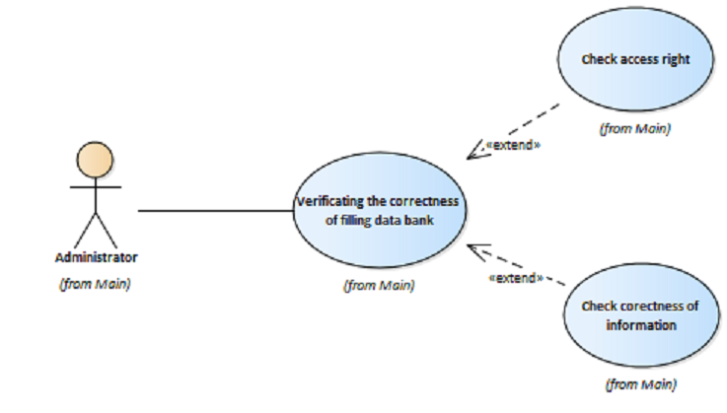

Verification of corectness of filling data bank